Directions to get Claims Summary from Medical Mutual Portal.
- Go to member.medmutual.com
- Log In (You may have to create an account.)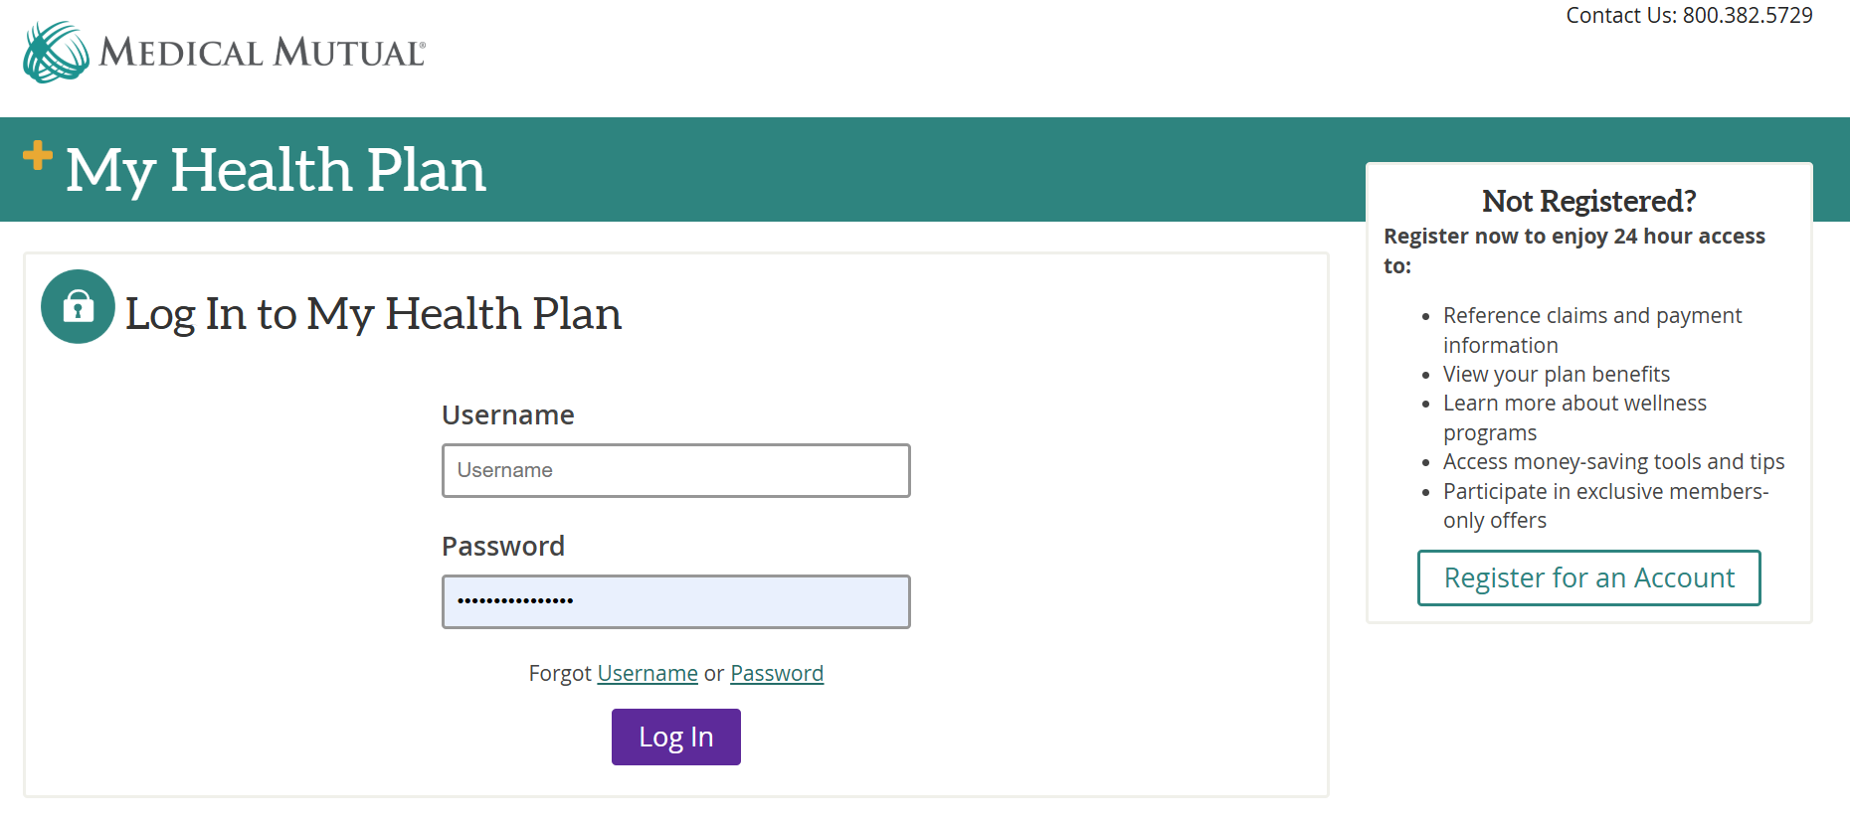
- On the Dashboard click “View Your Claims” 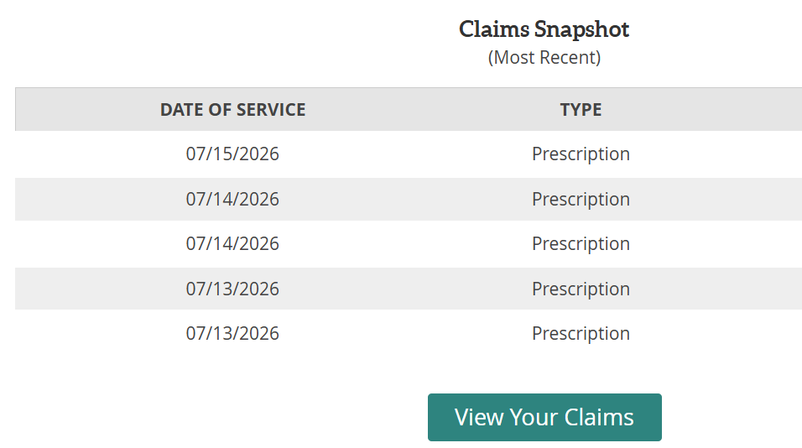
- In the Claims Summary section boxes
  - click “Select Date Range”.
  - Then, Start “1/1/2026”, and End “8/1/2026”.
  - View All Claim Type
  - View All Claim status.
  - Click apply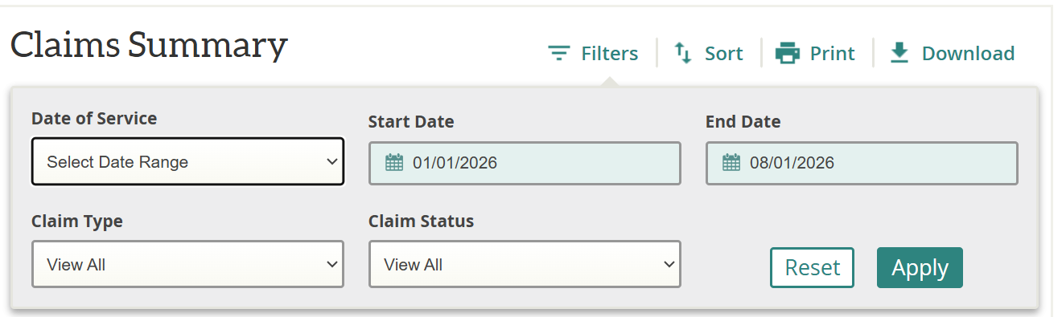
- Then click “Download” 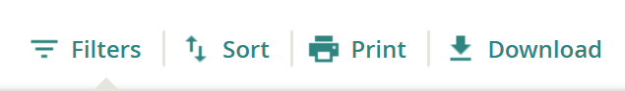
- Save the downloaded report to your computer.
- Send to Justin Grant via email. jgrant@ccao.org

